|  |
| --- |
|  |
| The Battle of Neighborhods |
|  |
|  |
| Opening new Turkish Restaurant in Bucharest, Romania  *IBM Data Science Professional Certificate – Capstone Project* |

*July 2020*

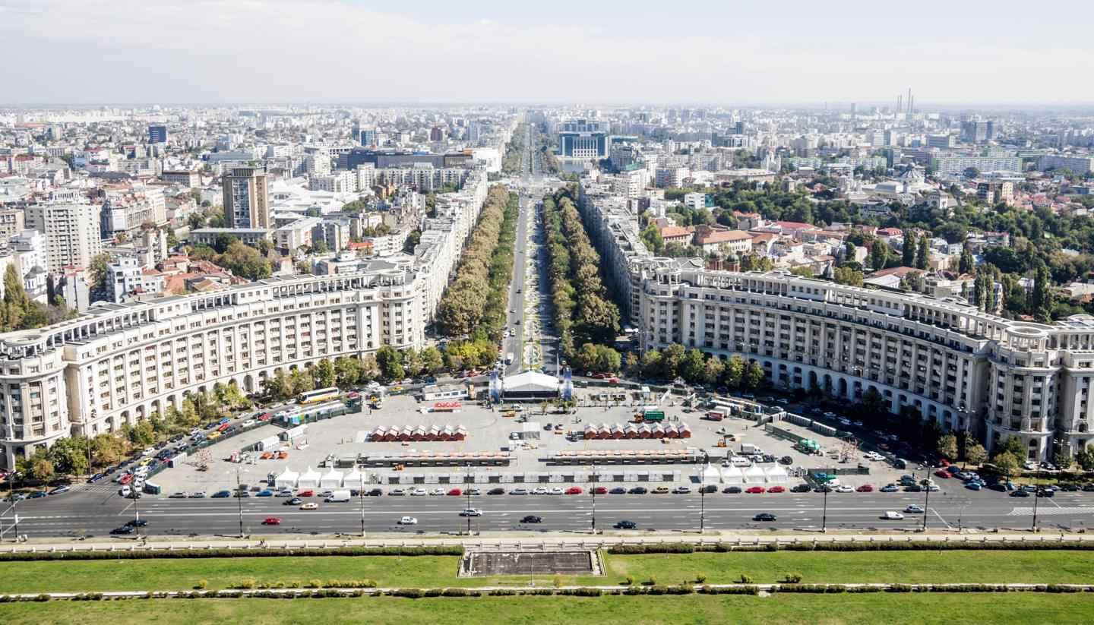

The Battle of Neighborhods

Opening new Turkish Restaurant in Bucharest, Romania

# 1. Introduction

## 1.1 Background

Bucharest is the capital and largest city of Romania, as well as its cultural, industrial, and financial center. It is located in the southeast of the country, at coordinates: 44°25′57″N 26°06′14″E, less than 60 km (37.3 mi) north of the Danube River and the Bulgarian border. [1]

Bucharest is the center of the Romanian economy and industry, accounting for around 24% (2017) of the country's GDP and about one-quarter of its industrial production, while being inhabited by 9% of the country's population. Bucharest has **1.883.425**(2018) populations and consists of **6 sectors**. Neighborhoods and populations in sectors are as below (2016): [1]

* **Sector 1** *(population 227,717):* Dorobanți, Băneasa, Aviației, Pipera, Primăverii, Dămăroaia, Grivița
* **Sector 2** *(population 357,338):* Pantelimon, Colentina, Iancului, Tei, Floreasca, Moșilor, Obor, Fundeni,
* **Sector 3** *(population 399,231):* Vitan, Dudești, Titan, Centrul Civic, Dristor, Lipscani
* **Sector 4** *(population 300,331):* Berceni, Olteniței, Progresul, Văcărești, Tineretului
* **Sector 5** *(population 288,690):* Rahova, Ferentari, Giurgiului, Cotroceni, 13 Septembrie, Dealul Spirii
* **Sector 6** *(population 371,060):* Giulești, Crângași, Drumul Taberei, Militari, Grozăvești(Regie), Ghencea

As stated by the Mercer international surveys for **quality of life** in **231** cities around the world, Bucharest occupied the **109th** place in 2019. Bucharest, at number 109, ranks low in the European list but better than other European cities such as Sofia (116th) and Belgrade (139th). [2]

Many neighborhoods, particularly in the southern part of the city, lack sufficient green space, are formed of cramped high density block of flats. This may affect people’s life as well.

## 1.2. Problem

This project aims to select the best location in Bucharest, Romania for opening a Turkish restaurant.

## 1.3. Interest

This project would be of interest to any entrepreneur who wants to open a new Turkish restaurant in Bucharest, Romania. In addition, the project can be modified for use to determine the best location to open a restaurant in any geographic location, and thus would be of interest more widely for any one who wants to open a restaurant or even any business where location is a key factor to the success of the business.

# 2. Data

## 2.1 Data Sources

To answer the business problem I utilised the below data sources:

* I got the sector data of Bucharest from Wikipedia [1]
* I got the neighborhood data of Bucharest from Wikipedia [3]
* I used python geocoder library to get geographical coordinates of neighborhoods[4]
* I used **Foursquare API** **venues explore** method to get the venues of given neighborhoods of Bucharest [5].
* I used **Foursquare API venues method** to get ranks and likes of restaurants by given venue id [5].

## 2.2 Feature Selection and Data Usage

* I will use neighborhood location values to analyze Bucharest geographical structure. I will use folium library of python to draw maps by using given latitude and longitudes of neighborhoods. Selected features will be as below

|  |  |  |  |
| --- | --- | --- | --- |
|  | **Neighborhood** | **Latitude** | **Longitude** |
| **0** | Aviației | 44.485790 | 26.101220 |
| **1** | Băneasa | 44.494010 | 26.080372 |
| **2** | Berceni | 44.386200 | 26.128960 |
| **3** | Bucureștii Noi | 44.484495 | 26.039608 |
| **4** | Centrul Civic | 44.434300 | 26.094660 |

* I will use populations of neighborhoods to determine neighbourhoods with large-sized populations whichh may need a new restaurant

|  |  |  |  |
| --- | --- | --- | --- |
|  | **Sector** | **Neigborhoods** | **Population** |
| **0** | Sector 1 | Dorobanți, Băneasa, Aviației, Pipera, Aviator... | 225,454 |
| **1** | Sector 2 | Pantelimon, Colentina, Iancului, Tei, Floreas... | 345,370 |
| **2** | Sector 3 | Vitan, Dudești, Titan, Centrul Civic, Balta A... | 385,439 |
| **3** | Sector 4 | Berceni, Olteniței, Văcărești, Timpuri Noi, T... | 287,828 |
| **4** | Sector 5 | Rahova, Ferentari, Giurgiului, Cotroceni, 13 ... | 271,575 |
| **5** | Sector 6 | Giulești, Crângași, Drumul Taberei, Militari,... | 367,760 |

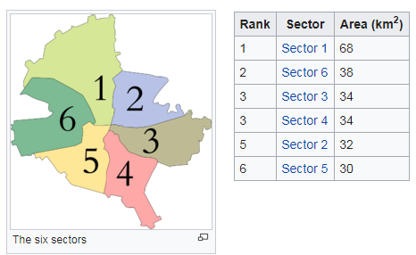

* I will also classify neighborhoods by using venues distribution and counts. In this way, I will find similarities between neighborhoods which will help me to choose a location for opening a new restaurant. Similarly structured neighborhoods may be conducive to the same type of venue/restaurant/business

* I will use venue list category to find distribution of restaurants and Turkish restaurants in neighborhoods

* I will also use ratings and likes of restaurants in the areas. This will help to find locations with poorly rated restaurants which may consequently desire the introduction of a new restaurant

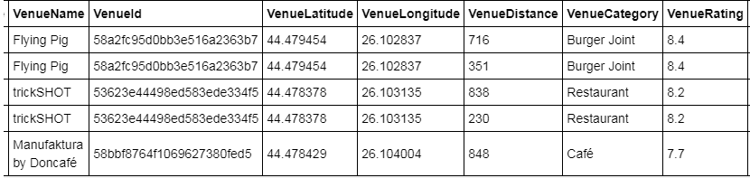

## References:

* [1] [Bucharest — Wikipedia](https://en.wikipedia.org/wiki/Bucharest)
* [2] [Mercer’s Quality of Life Survey](https://www.romania-insider.com/mercer-bucharest-quality-living-2019)
* [3] [Category:Districts of Bucharest](https://en.wikipedia.org/wiki/Category:Districts%20of%20Bucharest)
* [4] [Python Geocoder Library](https://geocoder.readthedocs.io/)
* [5] [Foursquare API](https://developer.foursquare.com/)

# 3. Methodology

* I used GitHub repository for code versioning.
* The Bucharest data is available with the neighborhood name in wikipedia. Location information (latitude and longitude) of neighborhoods are taken from geocoder library.
* I took neighborhood from wikipedia and put blue dots on Bucharest map to see centers of neighborhoods. There are **40** neighborhoods in Bucharest

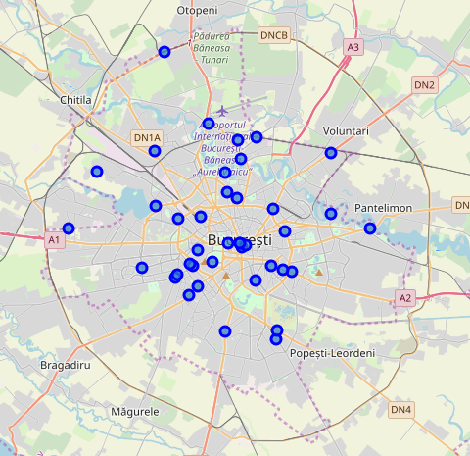

* I also got sector names of neighborhoods and populations of sectors. There are 6 sectors in Bucharest. I also merged Sector and Neighborhood data to see in which sector neighborhood places.

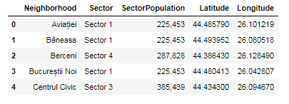

By using Foursquare API I got venues **1 km** around center of each neighborhood with limit **100 venue**. I merged data with Neighborhood data. Head of the merged data is as below

* There are 46 unique venue categories in Bucharest and top 10 venue counts is as below

* I filtered All restaurants and Turkish restaurant. We can see from histogram of restaurants, that no neighborhoods has any Turkish restaurant

* I used foursquare to get restaurant ratings by using venuid and merged with venue data

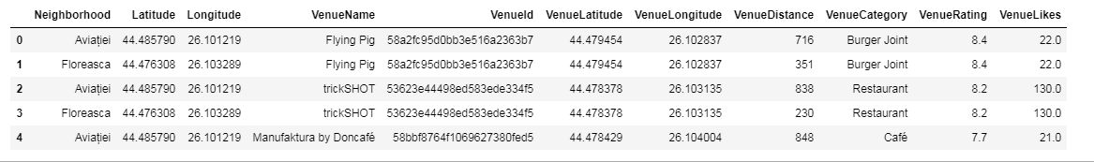

* I drew a heatmap for counts of restaurants in neighborhoods by using Folium library. On heatmap, I also drew 4 few circles indicating distance of 2km, 4km, 6km and 10km from Bucharest center.

I superimposed restaurants with **purple** markers and restaurants with ratings less than 7 with **blue** markers



* I used Agglomerative Clustering to cluster neighborhoods according to count of venue categories in each neighborhood. According to the below graph, I decided to separate the neighborhoods into 6 clusters (cut at distance of 20, horizontal black line). 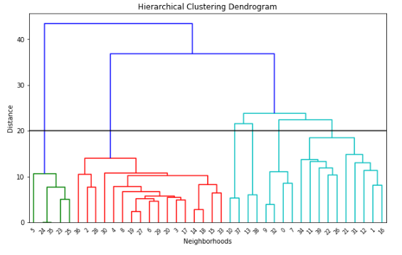

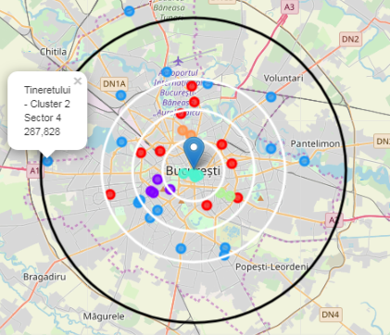 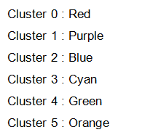

# 4. Results

I investigated that Turkish restaurant counts in Bucharest is 0.00%

* Total number of restaurants: 20
* Total number of Turkish restaurants: 0

From the bar chart, we can see

* Vitan is the neighborhood having most restaurants
* Dorobanti has lots of restaurants as well
* Odai and Gluesti are neighborhoods having least number of restaurants

From the heat maps, we can see that there are

* Too many restaurants in 2 km to the center
* Enough restaurants between 2-4 km to the center
* There are not many restaurants after 4 km to center

From the six clusters, we can see that the top 5 restaurant types are

* Coffee shops
* Hotels
* Dessert shops
* Italian restaurants
* Pizza places

The predominance of Italian restaurant might be taken to mean that people in Bucharest are open to cuisines from other countries.

# 5. Discussion

As there are no Turkish restaurants in all the neighborhoods explored, all neighborhoods are potential options. However taking into account the other factors outlined in the Results sections such as the predominance of restaurants in certain neighborhoods, the high number of restaurants close to the centre, the below 4 neighborhoods are where I would suggest a Turkish restaurant be opened in Bucharest:

* Neighborhood : Regie , Cluster 0, Sector 6 , Population : 367760

I chose Regie , since west part of Bucharest has not Turkish restaurant and Regie is close to center . Regie is red cluster which is same with the other 2 red markers having Turk restaurant. Red clusters populations may like Turkish food.

* Neighborhood : Bucureștii Noi , Cluster 2, Sector 1 , Population : 225453

I chose Bucharest-noi , since there is no Turkish restaurant here and because it is after 6 km distance to the centre where there are not too many restaurants. One restaurant will be good for this area.

* Neighborhood : Crângași , Cluster 2, Sector 6 , Population : 367760

I chose Crangasi , since Crangasi is in the West part of Bucharest and from the bar chart we can see that this neighborhood does not have a lot of restaurants. Also this neighborhood is in Sector 6 and this sector has biggest population which will be ahandle one more restaurant

* Neighborhood : Tineretului , Cluster 2, Sector 4 , Population : 287828

I chose Tineretului , since Tineretului has not Turkish restaurant and from bar chart we can see that this neighborhood has not too much restaurant.

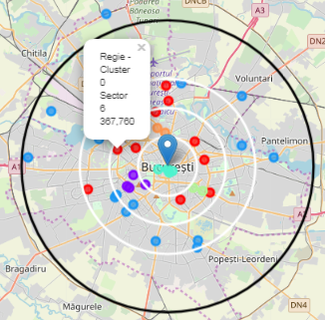 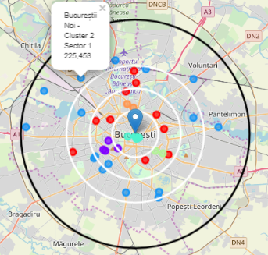

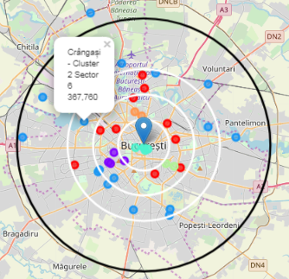 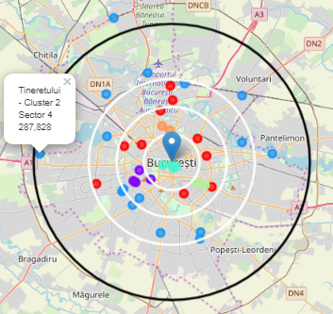

# 6. Conclusion

Using the data sources and methodologies outlined above, I was able to arrive at 4 possible neighborhoods where a Turkish restaurant can be opened.

* Regie
* Bucureștii Noi
* Crângași
* Tineretului